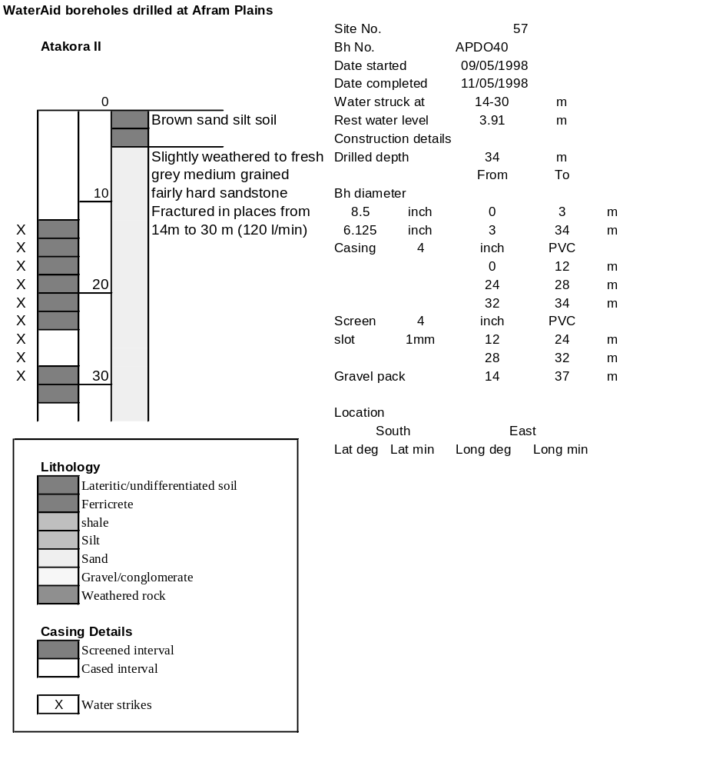

Ghana | Test pumping
Borehole No. |  | APDO40
Hole No |  | 57 | (7)
Village |  | Atakora II
Date |  | 18/11/1998
Point above GL |  | 0.63 | m
Pump depth |  | 26 | m
SWL |  | 4.54 | m
Start Time |  | 08:30
Drawdown test |  |  |  |  | Recovery Test
time | pwl (m) | Q l/min | dd | sc(q/s) | Time | wl (m) | t/t' | resdd
0.00 | 4.54 | 85.00 | 0.00 |  | 0.00 | 9.78 |  | 5.24
1.00 | 8.30 | 85.00 | 3.76 | 22.61 | 1.00 | 5.31 | 241.00 | 0.77
2.00 | 9.01 | 85.00 | 4.47 | 19.02 | 2.00 | 5.15 | 121.00 | 0.61
3.00 | 9.23 | 85.00 | 4.69 | 18.12 | 3.00 | 5.10 | 81.00 | 0.56
4.00 | 9.23 | 85.00 | 4.69 | 18.12 | 4.00 | 5.05 | 61.00 | 0.51
5.00 | 9.23 | 85.00 | 4.69 | 18.12 | 5.00 | 5.03 | 49.00 | 0.49
6.00 | 9.24 | 85.00 | 4.70 | 18.09 | 6.00 | 5.00 | 41.00 | 0.46
7.00 | 9.27 | 85.00 | 4.73 | 17.97 | 7.00 | 4.99 | 35.29 | 0.45
8.00 | 9.29 | 85.00 | 4.75 | 17.89 | 8.00 | 4.97 | 31.00 | 0.43
9.00 | 9.31 | 85.00 | 4.77 | 17.82 | 9.00 | 4.95 | 27.67 | 0.41
10.00 | 9.31 | 85.00 | 4.77 | 17.82 | 10.00 | 4.94 | 25.00 | 0.40
12.00 | 9.31 | 85.00 | 4.77 | 17.82 | 12.00 | 4.92 | 21.00 | 0.38
14.00 | 9.33 | 85.00 | 4.79 | 17.75 | 14.00 | 4.90 | 18.14 | 0.36
16.00 | 9.34 | 85.00 | 4.80 | 17.71 | 16.00 | 4.88 | 16.00 | 0.34
18.00 | 9.35 | 85.00 | 4.81 | 17.67 | 18.00 | 4.86 | 14.33 | 0.32
20.00 | 9.36 | 85.00 | 4.82 | 17.63 | 20.00 | 4.85 | 13.00 | 0.31
25.00 | 9.38 | 85.00 | 4.84 | 17.56 | 25.00 | 4.82 | 10.60 | 0.28
30.00 | 9.40 | 85.00 | 4.86 | 17.49 | 30.00 | 4.80 | 9.00 | 0.26
35.00 | 9.41 | 85.00 | 4.87 | 17.45 | 35.00 | 4.77 | 7.86 | 0.23
40.00 | 9.44 | 85.00 | 4.90 | 17.35 | 40.00 | 4.76 | 7.00 | 0.22
45.00 | 9.46 | 85.00 | 4.92 | 17.28 | 45.00 | 4.75 | 6.33 | 0.21
50.00 | 9.48 | 85.00 | 4.94 | 17.21 | 50.00 | 4.73 | 5.80 | 0.19
55.00 | 9.49 | 85.00 | 4.95 | 17.17 | 55.00 | 4.70 | 5.36 | 0.16
60.00 | 9.50 | 85.00 | 4.96 | 17.14 | 60.00 | 4.69 | 5.00 | 0.15
70.00 | 9.53 | 85.00 | 4.99 | 17.03 | 70.00 | 4.68 | 4.43 | 0.14
80.00 | 9.56 | 85.00 | 5.02 | 16.93 | 80.00 | 4.66 | 4.00 | 0.12
90.00 | 9.60 | 85.00 | 5.06 | 16.80 | 90.00 | 4.64 | 3.67 | 0.10
100.00 | 9.61 | 85.00 | 5.07 | 16.77 | 100.00 | 4.65 | 3.40 | 0.11
110.00 | 9.63 | 85.00 | 5.09 | 16.70 | 110.00 | 4.64 | 3.18 | 0.10
120.00 | 9.65 | 85.00 | 5.11 | 16.63 | 120.00 | 4.64 | 3.00 | 0.10
130.00 | 9.67 | 85.00 | 5.13 | 16.57
140.00 | 9.68 | 85.00 | 5.14 | 16.54
150.00 | 9.70 | 85.00 | 5.16 | 16.47
160.00 | 9.72 | 85.00 | 5.18 | 16.41
170.00 | 9.73 | 85.00 | 5.19 | 16.38
180.00 | 9.75 | 85.00 | 5.21 | 16.31
190.00 | 9.75 | 85.00 | 5.21 | 16.31
200.00 | 9.77 | 85.00 | 5.23 | 16.25
210.00 | 9.78 | 85.00 | 5.24 | 16.22
220.00 | 9.77 | 85.00 | 5.23 | 16.25
230.00 | 9.77 | 85.00 | 5.23 | 16.25
240.00 | 9.78 | 85.00 | 5.24 | 16.22

